Solution Requirements(Functional & Non-functional)

Date | 19/02/2026
Team ID | LTVIP2026TMIDS66407
Project Name | AUTOMATIC CAR CATALOG SYSTEM FOR ENHANCED SHOWROOM MANAGEMENT
Maximum Marks | 4Marks

Functional Requirements:
The Following are the functional requirements:

Fr. No | Functional Requirements | Sub-Functional Requirements
1 | Service catalog | Create catalog Create categories
2 | User creation | Create a user
3 | Role creation | Create role
4 | Group creation | Create group
5 | Table creation | Create table
6 | Workflow | Workflow assignment to mahindra Service catalog
7 | Service portal | Searching created catalog are available in  Service portal
8 | Result | Check result

Non-Functional Requirements:

The Following are the non-functional requirements:

NFr. No | Nonfunctional  requirements | Description
1 | Usability | As described previously How easy and  intuitive the platform is for users to Interact with.
2 | Security | Measures to protect data, prevent unauthorized access, and ensure compliance(e.g : encryption, access  controls).
3 | Reliability | How consistently the system performs as expected, without failures or errors.
4 | Performance | How fast the system responds(e.g : page  loadtimes, response time for queries).
5 | Availability | The percentage of time the system is operational and accessible(e.g. uptime,  Disaster recovery).
6 | Scalability | The ability of the system to handle  Increasing numbers of users, data, or transactions without degradation

Data Flow Diagram:

A Data Flow Diagram (DFD) is a graphical representation of how data moves through a system. It shows where data comes from, how it is processed, where it is stored, and where it goes—without focusing on technical details like code or hardware.
Think of it as a map of data movement inside an information system.

Meaning of Data Flow Diagram (DFD)
A DFD illustrates the flow of data between:
- External entities (users or other systems),

- Processes (activities that transform data),
- Data stores (places where data is held),
- Data flows (paths data takes). It answers questions like:
- Where does the data originate?
- What happens to the data?
- Where is the data stored?
- Who receives the data?

Purpose of Data Flow Diagram :
The main purpose of a DFD is to analyze, design, and communicate how a system handles data in a clear and simple way.

Key purposes include:
- Understanding the System
  - Helps analysts and users understand how the system works logically.
  - Breaks down complex systems into simpler parts.

Improving Communication
  - Acts as a common language between developers, analysts, and non-technical users.
  - Easy to understand because it uses symbols instead of technical jargon.

System Analysis and Design
  - Helps identify missing data, redundant processes, or inefficiencies.
  - Used during system planning and requirement analysis.

Documentation
  - Serves as a visual record of system functionality.
  - Useful for future maintenance or system upgrades.

Important Points of Data Flow Diagram
- Main Components of a DFD
  - External Entity – Source or destination of data (e.g., Customer, Bank)
  - Process – Transforms input data into output (e.g., Process Order)
  - Data Store – Stores data (e.g., Database, File)
  - Data Flow – Shows movement of data (arrows)

Levels of DFD
  - Context Diagram (Level 0) – Shows the entire system as one process.
  - Level 1 DFD – Breaks the main process into sub-processes.

  - Level 2 DFD and beyond – Further detailed breakdowns.

Focus on Logic, Not Technology
  - DFD shows what the system does, not how it is implemented.
  - No programming or hardware details are included.

Rules to Remember
  - Every process must have input and output.
  - Data stores cannot exchange data directly with external entities.
  - Data flows must be clearly named.

In Simple Words
A Data Flow Diagram helps you see how data moves and changes inside a system, making it easier to analyze, design, and improve that system.















Service Catalog
Role Creation
User Creation
Group Creation
WorkFlow
Service Portal
Result

Fig ; Data Flow Diagram

Technology Stack :
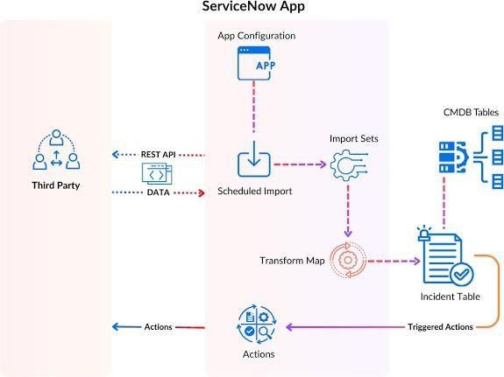
Fig : Architecture of ServiceNow

Overview :
- ThirdParty(Leftside)
External systems or applications(e.g.,monitoring tools,databases,CMDBs)are referred to as "Third Party". These systems send data to ServiceNow through RESTAPIs.

RESTAPI&DATA

The third-party system communicates with ServiceNow using RESTAPIs.
Data is pushed or pulled via API’s and is then passed to the next processing stage in ServiceNow.

Scheduled Import

The incoming data is managed using Scheduled Import jobs.
These jobs are configured in the ServiceNowAppConfiguration and determine when and how data should be imported.

Import sets

Once data reaches ServiceNow,it goes into Import Sets,which acts as staging tables to temporarily hold the data.

TransformMap

Transform Maps define howdata in the ImportSets should be mapped to the target tables.

It transforms and processes raw input data to align with the structure of target tables(like Incident or CMDB tables).

Target Tables :

These are the final destinations for processed data:

CMDBTables(ConfigurationManagementDatabase):Used for storing configuration items and their relationships.
Incident Tables : For Storing Incident Records Other Relavent Business Specific Tables

Triggered Actions :

Once data reaches the set tables, Triggered Actions can take place.

These actions might include workflows, notifications,or integrations with other ServiceNow modules.

